The models of user are shown in the UML diagram below

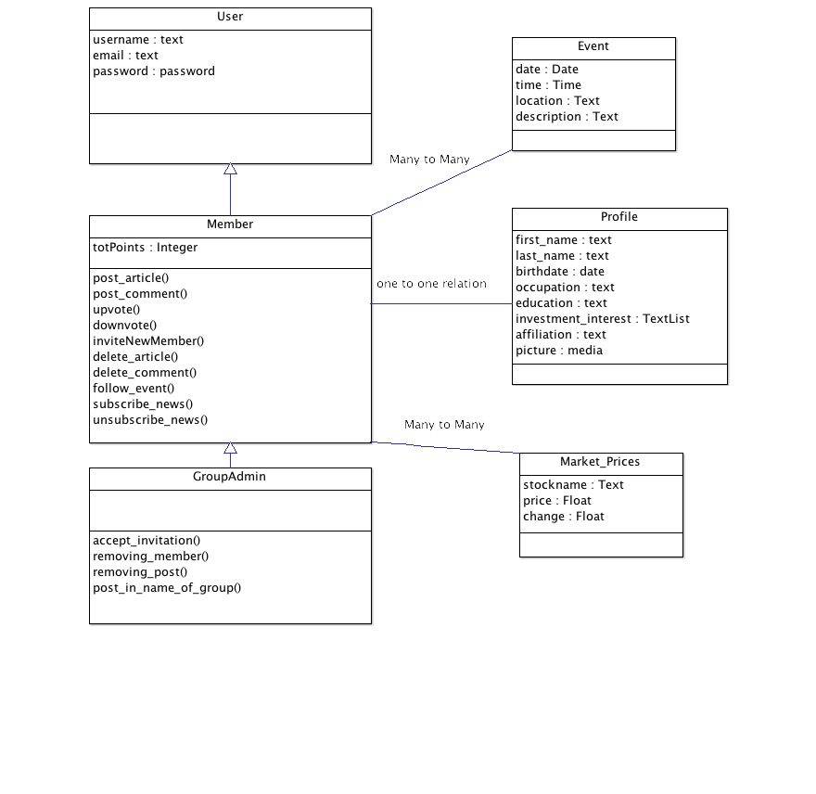

Description of models:

* *User* is the generic model of users of MoneyClub, which has three attributes:
  + username
  + email
  + password

A new user is unable to join any group unless she/he is invited by one group member and accepted by the group admin.

* *Member* is the generic model of group members. *Member* inherits from the *User* model

Attributes:

* + totPoints: the overall points a group member earned from each of her/his groups. The individual points is defined in the member-group mapping model.

Methods:

* + post_articles: A group member can post articles in her/his groups. An article can be a text post, a link, a multi-media (video/image) or an event.
  + delete_article: A group member can delete her/ his own article
  + post_comment: A group member can comment on other members’ articles or comments.
  + delete_comment: A group member can delete her/his own comment.
  + upvote()/downvote() : A member can upvote/downvote others’ posts or comment. The corresponding member will be added/deducted points
  + inviteNewMember(): To invite a new member to the group.
  + follow_event(): To follow an event. A member automatically follows the event her/himself starts.
  + subscribe_news() / unsubscribe_news(): To subscribe/unsubscribe the newest market indices interested, such as DOW, S&P, FTSE, Gold, Google, etc.
* *GroupAdmin* inherits the *Member* model. A group admin manages a group. A group has couples of admins.

Methods:

* + accept_invitation(): to accept the request for adding a new member
  + removing_member(): to remove a member from the group, a given proper reason
  + removing_post() : to remove a member’s posts (articles or comments), given a proper reason.
  + post_in_name_of_group() : to post in the name of the group.
* *Profile* stores the information of a member of the MoneyClub

Attributes:

* + first_name / last_name;
  + birthdate;
  + occupation;
  + education;
  + affiliation;
  + picture: a profile picture;
  + investment_interest: a list of the member’s investment_interest. A member’s interests are supposed to intersect with the group’s interest
* *Event* stores the information of an event

Attributes:

* + date / time;
  + location;
  + description
* *Market_Prices* provides real time prices of the market

Attributes:

* + stockname: the name of the stock or market or merchandise
  + price: real time price
  + change: absolute or percentage change since last trade day

Functionalities complete by the next sprint:

* Create the *User* model
* Create the form and modelform of the *Profile*  model
* Create the *Member* model; implement all the methods except for follow_event(), un/subscribe_news().
* View the models and functionalities smoothly.